EZ Nuc Folding Instructions

STEP 1: TAKE OUT THE FLAT BOX AND SEE ALL FOLD MARKS AS BELOW  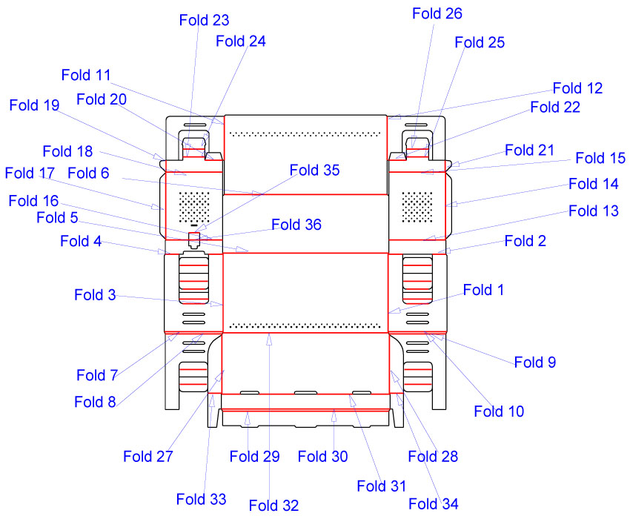 | STEP 2 : Fold flap 32 (lid hinge) back and forth 5 or 6 times to soften the hinge so the lid will stay closed once the NUC is assembled  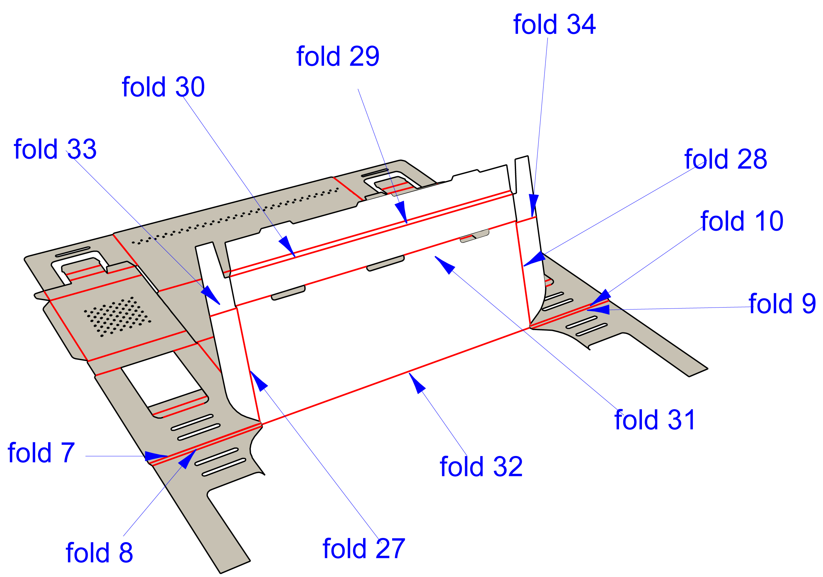
STEP 3 – FOLD CREASE 1,2,3,4 AS SHOWN BY 90 DEGREE  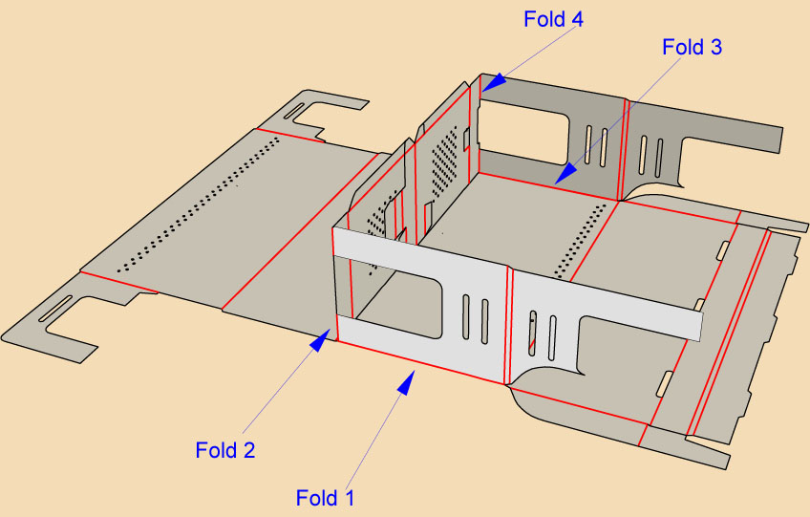 | STEP 4- FOLD CREASE 5,6  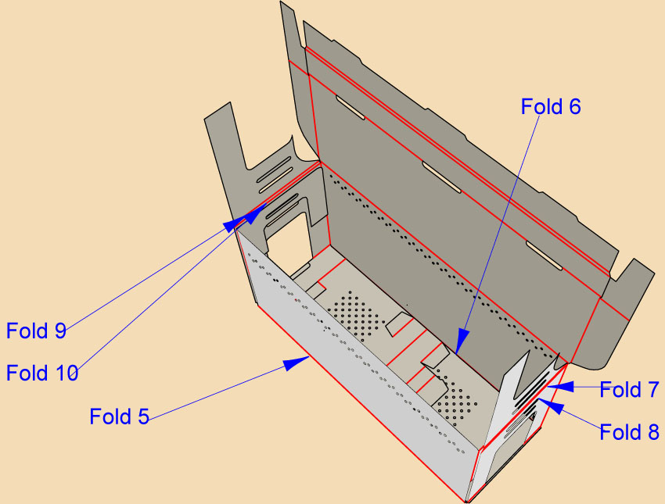
STEP 5- FOLD 7,8,9,10  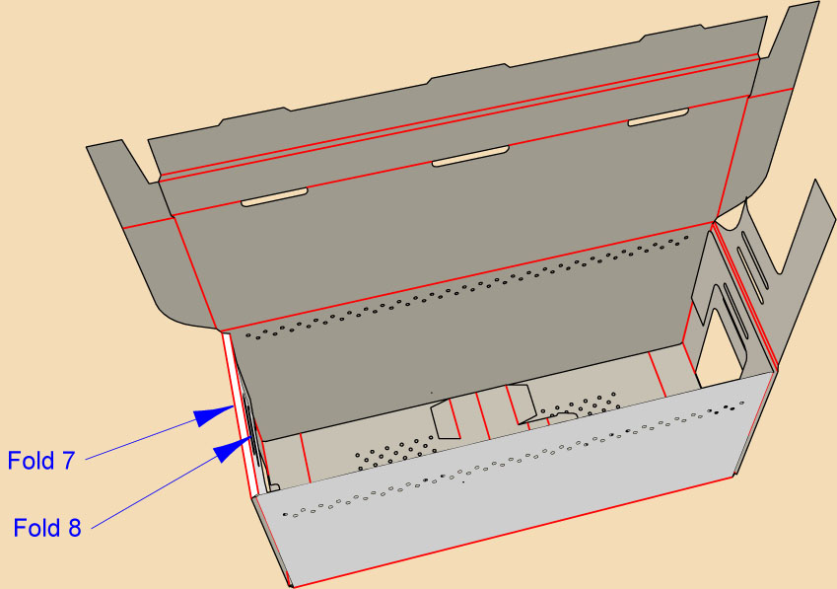 | STEP 6- FOLD 16,18,20 & 13,15,22 AND INSERT BOTH SIDE FLAPS IN TOP SLOTS  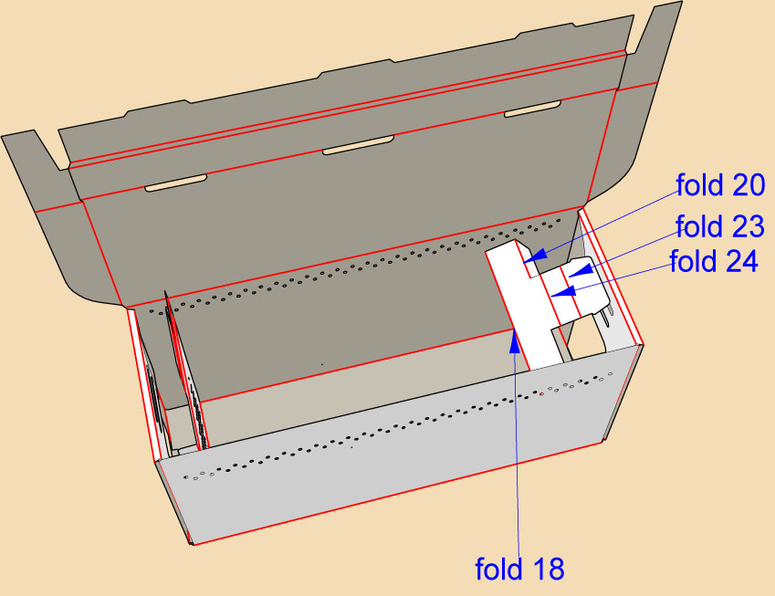

STEP 7- FOLD 33,27 & 34,28  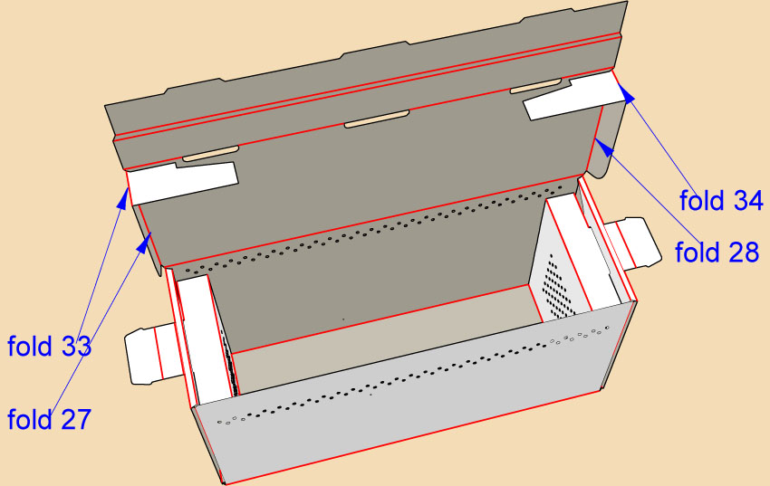 | STEP 8- FOLD 31 AND KEEPING FLAP INSIDE FOLD 29 & 30 TO LOCK IN THREE COVER SLOTS  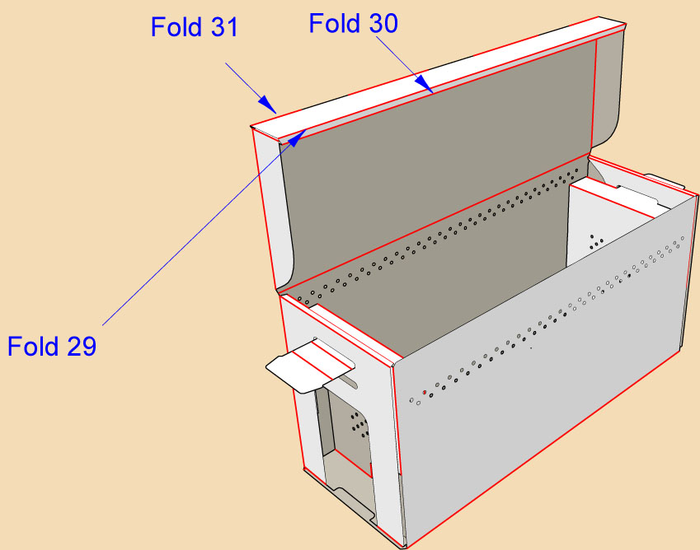
STEP 9- FOLD 23,24 & 25,26 AND TAKING THE FLAP A LITTLE BACK INSERT WITH LITTLE FORCE FLAP IN THE LOWER SLOT ON BOTH SIDES  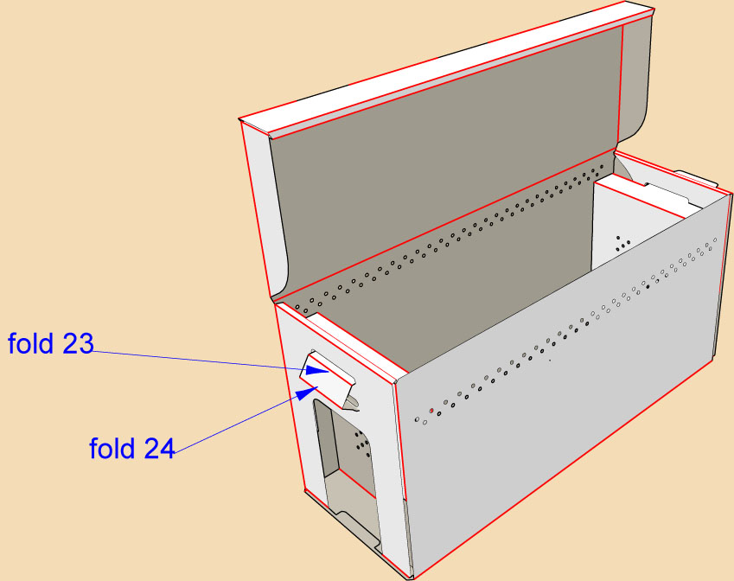 | STEP 10- TRAP DOOR CAN BE OPENED BY PUSHING IT BACK AND PICKING THE DOOR UP AND LOCKING THE TAB IN THE SMALL SLOT AT TOP OF DOOR  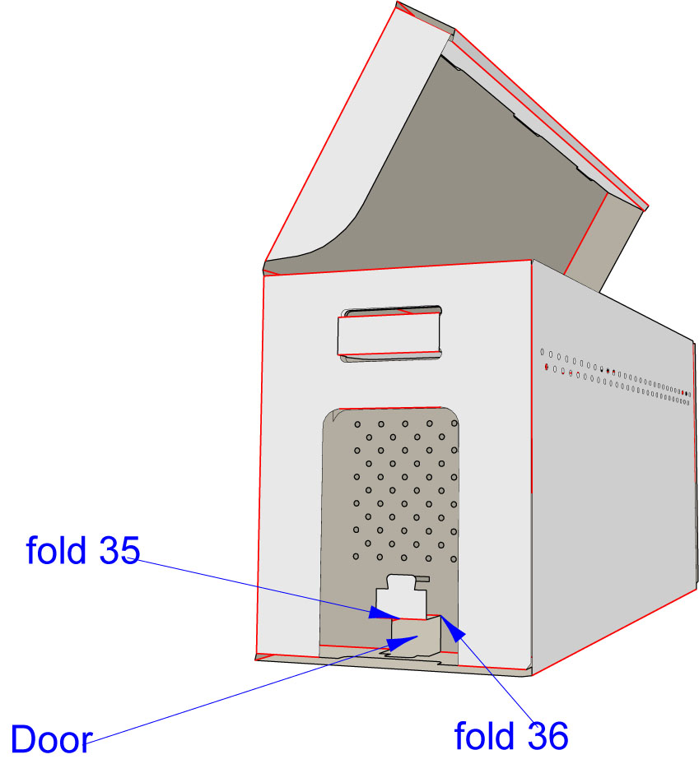
STEP 11- YOUR NUC IS NOW COMPLETE
